Medical Care Collections Fund (MCCF) eBilling

Electronic Data Interchange (EDI)

Transactions Applications Suite (TAS)

Interface Control Document

For the interface between MCCF EDI TAS and

The Financial Service Center (FSC)

ASC X12N/005010 837 Health Care Claims

Logo for the Department of Veterans Affairs, Office of Information and Technology, Product Development, including the official seal of the Department of Veterans Affairs


Department of Veterans Affairs

August 2018

Version 3.8

Revision History

|  |  |  |  |
| --- | --- | --- | --- |
| Date | Version | Description | Author |
| 2/23/18 | 0.0.1 | Initial creation of document | Steffen Maerdian - Halfaker & Associates |
| 2/28/18 | 0.0.2 | Formatting and content updates for initial draft | Keith Oulson – Halfaker & Associates |
| 3/1/18 | 1.0 | Finalization of draft | Steffen Maerdian - Halfaker & Associates |
| 3/19/18 | 1.5 | Incorporation of review comments from eBilling and Technical Writer | Keith Oulson – Halfaker & Associates |
| 3/26/18 | 2.0 | Review | Steffen Maerdian - Halfaker & Associates |
| 04/05/2018 | 2.5 | Review | EDI BA’s |
| 04/10/2018 | 3.0 | Review | Sarah Snyder,  ECD Project Manager - GCIO |
| 04/12/2018 | 3.1 | Incorporating FSC Review Comments | Keith Oulson – Halfaker & Associates |
| 04/18/2018 | 3.2 | Adding elaborated testing sections from ICD call | Steffen Maerdian - Halfaker & Associates |
| 04/19/2018 | 3.3 | Adding latest mapping sheet | Steffen Maerdian - Halfaker & Associates |
| 04/25/2018 | 3.31 | Corrected signature page according to Frank Annecchini | Keith Oulson – Halfaker & Associates |
| 04/26/2018 | 3.4 | Added reviewed and corrected 837P.json file | Steffen Maerdian - Halfaker & Associates |
| 05/26/2018 | 3.5 | Added reviewed and corrected 837I.json file | Steffen Maerdian - Halfaker & Associates |
| 05/26/2018 | 3.6 | Added reviewed and corrected 837D.json file | Steffen Maerdian - Halfaker & Associates |
| 5/29/2018 | 3.61 | Added latest mapping sheet | Keith Oulson – Halfaker & Associates |
| 7/31/2018 | 3.7 | Update mapping sheet and JSON files after finishing development of 837 FHIR mappings | Steffen Maerdian - Halfaker & Associates |
| 8/23/2018 | 3.8 | Update mapping sheet: Column K is now filled out for every field. One change in segment (Column L highlighted blue). Some changes in mappings (Column J highlighted blue). Deleted FHIR mappings for field one (RECORD ID) for each segment.  Updated section 3.3 and replaced JSON files with actual JSON files from development environment.  Updated section 4. | Steffen Maerdian - Halfaker & Associates |
|  |  |  |  |

Table of Contents

1 Introduction 1

1.1 Purpose 1

1.2 Scope 1

1.3 System Identification 1

1.3.1 MCCF EDI TAS 1

1.3.2 FSC 2

1.4 Operational Agreement 2

2 Interface Definition 2

2.1 System Overview 3

2.1.1 Overview Diagram 3

2.2 Interface Overview 5

2.2.1 Connectivity between the systems 5

2.3 Operations 6

2.3.1 Data Extraction 6

2.3.2 Data Transformation 6

2.3.3 Sending/Receiving 6

2.4 Data Transfer 6

2.5 Transaction Types 6

2.6 Data Exchanges 6

2.6.1 FHIR Based Resources 7

2.6.2 JSON Format 9

2.6.3 Bundle Definition 10

2.7 Communications Methods 11

2.7.1 Ports and Protocols 11

2.7.2 ESB Configuration(s) 12

2.7.3 System Configuration 12

2.8 Performance Requirements 12

2.9 Security 12

2.10 Testing Requirements 12

2.10.1 Comparison of Data 13

2.10.2 Completeness 13

2.10.3 Load Testing 13

2.11 Policies and Constraints 13

2.11.1 HIPAA Compliance 14

3 Appendix A 15

3.1 Data Elements 15

3.2 Bundle (837) 15

3.2.1 837 Health Care Claims Bundles 15

3.3 Resource Sections 16

3.3.1 837I Transaction Resources 16

3.3.2 837P Transaction Resources 17

3.3.3 837D Transaction Resources 18

3.3.4 Mapping Sheet 19

4 Appendix B - TASCore Mapping Rules 19

4.1 Mapping rules for Patient.gender 19

4.2 Mapping rules for telecom.system 20

4.3 DateTime types in FHIR 20

5 Appendix C – TASCore Default Values 22

6 Appendix D – FSC Mapping Rules 22

7 Appendix E – FSC Default Values 22

8 Glossary 22

9 Attachment A – Approval Signatures 22

Table of Figures

Figure 1– Interim Solution Diagram 3

Figure 2 - Future (To Be) Solution Diagram 4

Figure 3 - TASCore/FSC Connectivity 5

Figure 4 – Example FHIR Bundle Content 10

Figure 5 – Example FHIR Bundle 11

# Introduction

This document describes the interface between a MCCF EDI TAS application and the VA Financial Services Center in Austin, TX (FSC) related to the electronic processing of ASC X12N/005010 837 Health Care Claims (837) messages.

## Purpose

The purpose of this Interface Control Document (ICD) is to define the message structure and protocols which govern the interchange of data between eBilling within MCCF EDI TAS and the FSC related to the electronic processing of 837 messages.

## Scope

This ICD specifies the interface between MCCF EDI TAS and FSC. This document provides details on the functional, performance, operational and design requirements for the interface. This document defines the layouts for the data that the MCCF EDI TAS sends to FSC. This document is intended for all parties requiring such information, including business stakeholders, business analysts, software developers, system designers, testers and anyone else responsible for implementing this interface.

## System Identification

MCCF EDI TAS eBilling is software designed to support the requests inquiries and responses related to Health Care Claims sent to and received from the FSC. This interface supports the electronic transmission of 837 messages between FSC and MCCF EDI TAS.

### MCCF EDI TAS

|  |  |
| --- | --- |
| System | Details |
| Title | TBD |
| Abbreviation | TBD |
| Version number | TBD |
| Release number | TBD |
| Point of Contact | TBD |
| Vendor [optional] | TBD |

The TAS Platform will modernize and automate the business processes used currently as part of the VA revenue cycle. This includes insurance verification, billing, and claims processing, payment, and remittance. These processes are tied to other processes that are out of scope, including documenting the care provided, coding treatment and encounters, and sending claims and receiving remittance to and from the clearinghouse.

This interface supports the electronic third-party billing process which involves the electronic transmission of 837 messages to VA Healthcare Clearing House (HCCH), the VA’s clearinghouse, where claims are either transmitted to the insurance company or sent to a printing facility.

### FSC

|  |  |
| --- | --- |
| System | Details |
| Title | TBD |
| Abbreviation | TBD |
| Version number | TBD |
| Release number | TBD |
| Point of Contact | TBD |
| Vendor [optional] | TBD |

The system(s) at FSC, receives the data from the TAS Platform, translates the data into a standard ASC X12N/005010 837 Health Care Claims transmission, validates the data complies with HIPAA standards and then forwards the claim data to HCCH.

## Operational Agreement

This ICD provides the specification for an interface between MCCF EDI TAS and FSC regarding Health Care Claims data. The Chief Business Office (CBO) is responsible for notifying FSC personnel of any potential or planned changes to data feeds once these changes are known to minimize adverse impacts.

# Interface Definition

Health Care Claims data is transmitted between the FSC and MCCF EDI TAS in FHIR bundles.

## System Overview

MCCF EDI TAS eBilling is designed to create claims for reimbursement from third party payers for health care services rendered to the patient by the Department of Veteran’s Affairs when the patient has private insurance or is eligible for Medicare. The MCCF EDI TAS eBilling software can create claims based on data received from the patient’s inpatient and/or outpatient patient record.

### Overview Diagram

Interim solution

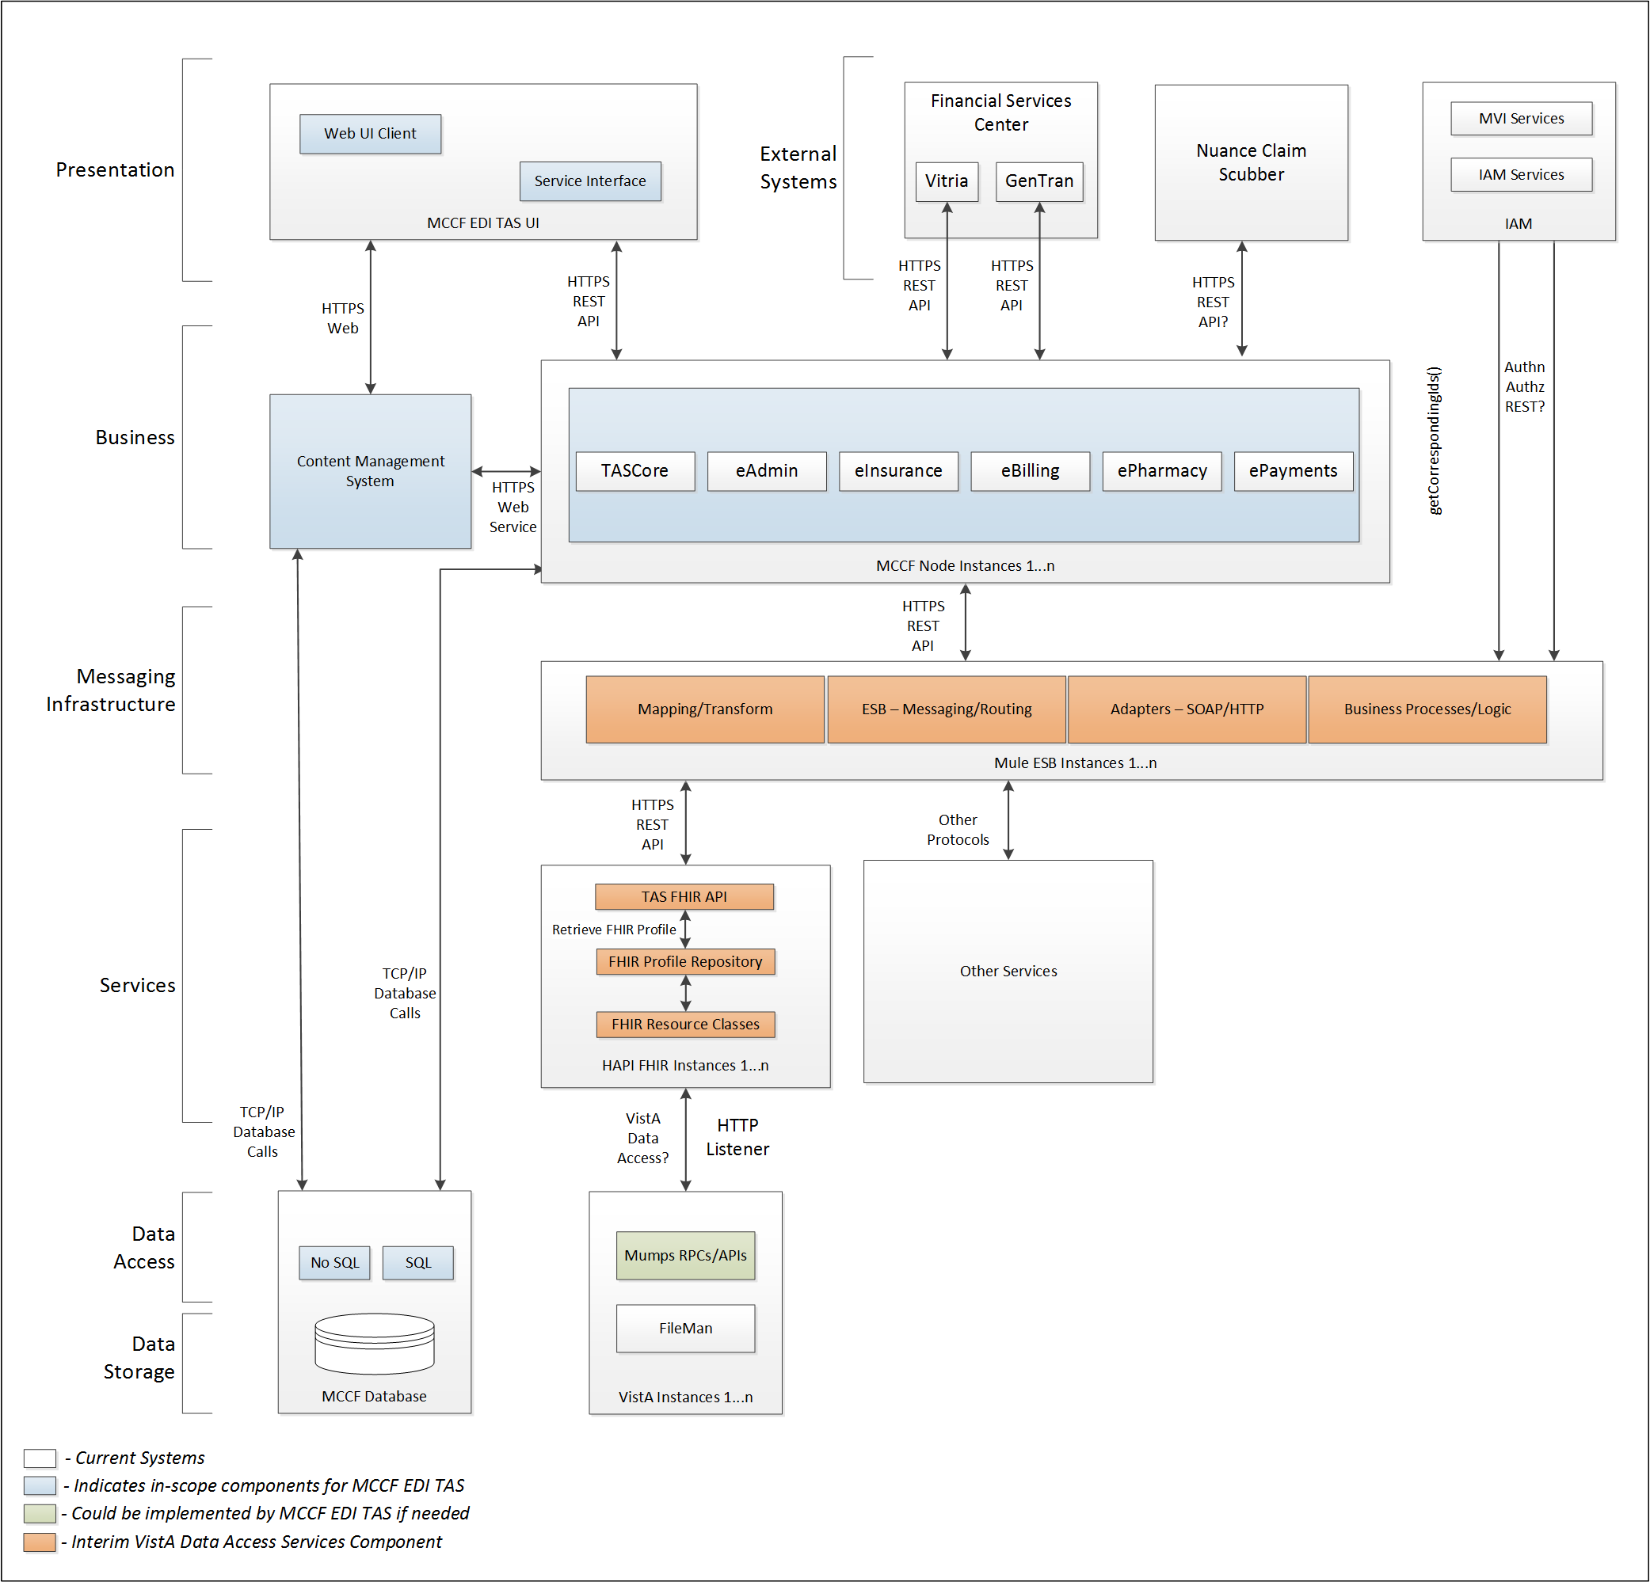

Figure – Interim Solution Diagram

To be solution

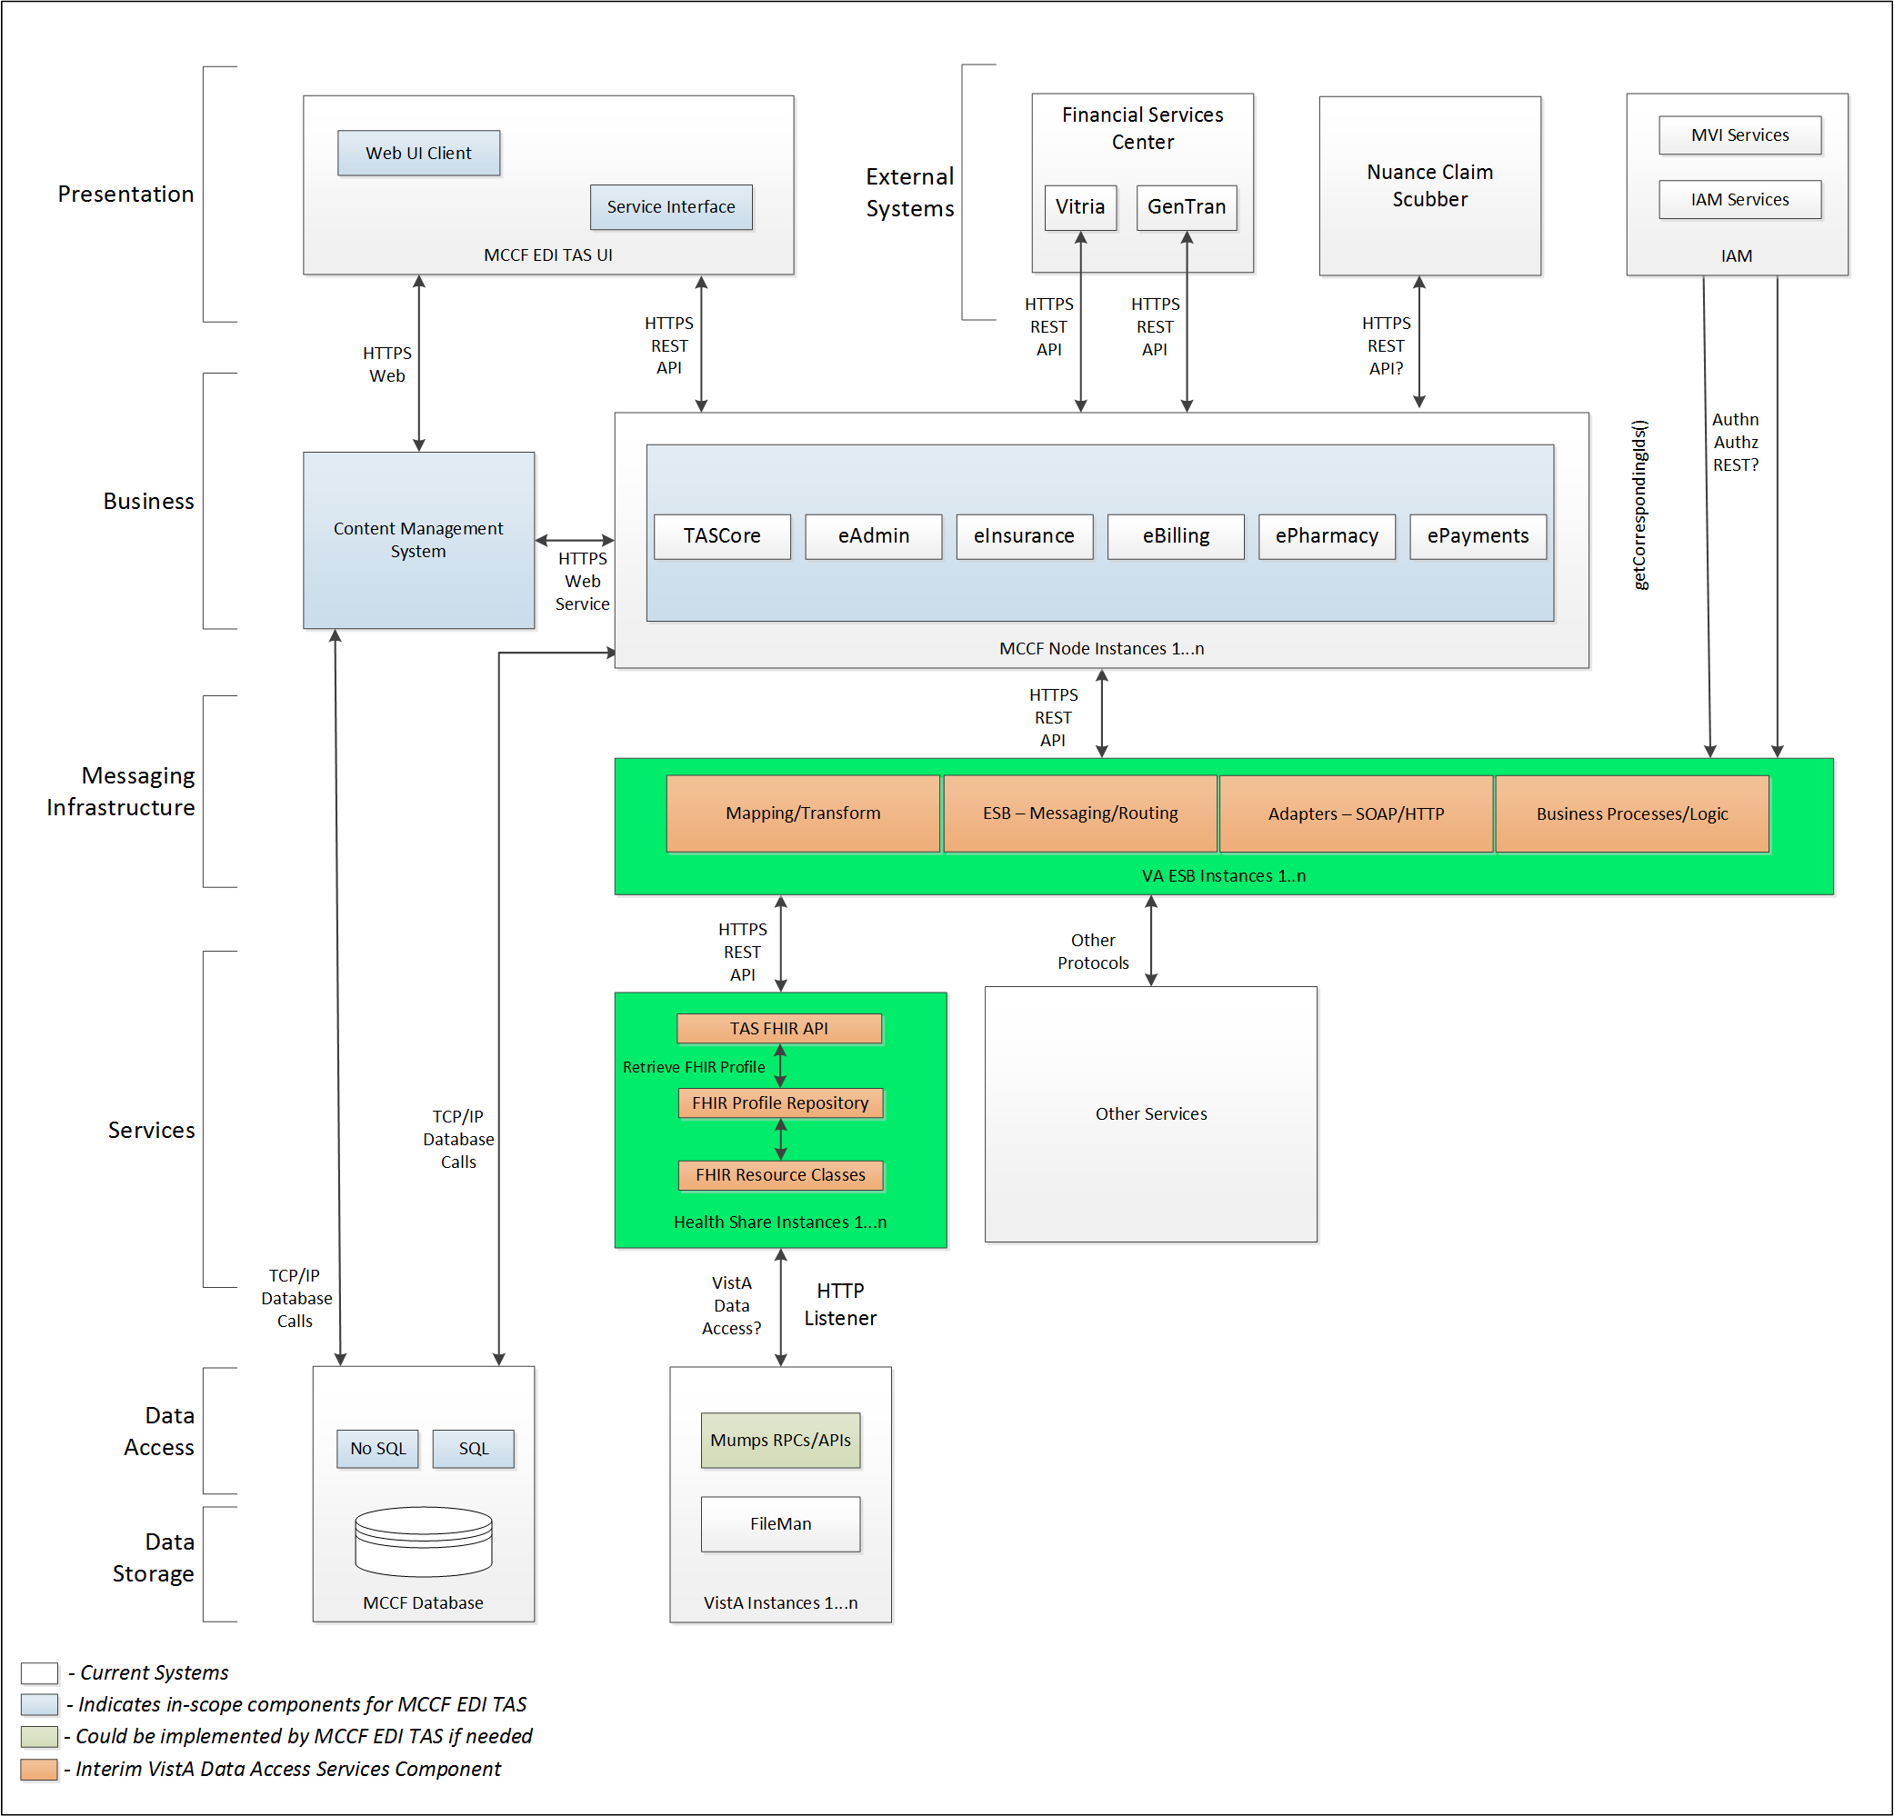

Figure - Future (To Be) Solution Diagram

## Interface Overview

The messages exchanged between MCCF EDI TAS eBilling and FSC can be done in real time or as queued messaging.

### Connectivity between the systems

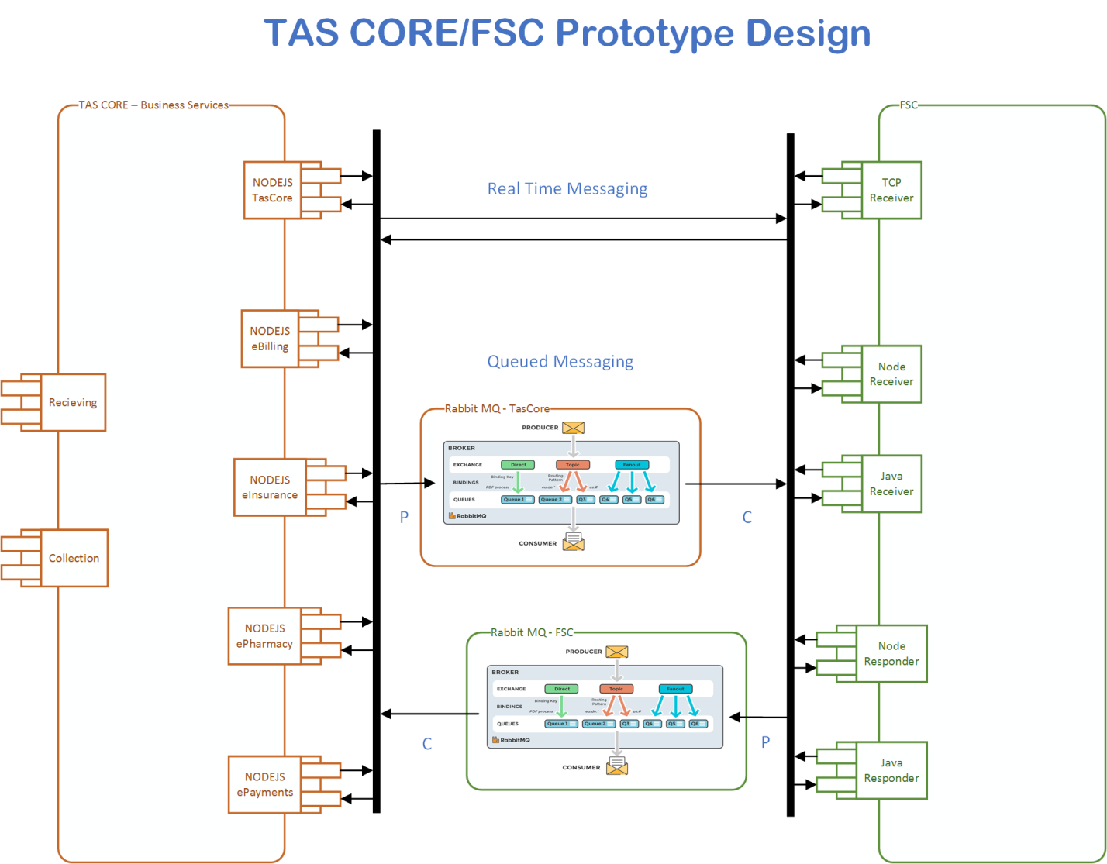

Figure - TASCore/FSC Connectivity

## Operations

TBD

### Data Extraction

Data being sent to FSC will be extracted from the VistA databases using a FHIR server.

### Data Transformation

Data transformations to the 837 X12 transaction will be performed by the FSC upon FHIR bundled resources provided by the eBilling and TASCore teams.

### Sending/Receiving

MCCF EDI TAS eBilling sends 837 messages to FSC.

## Data Transfer

Data is transferred between the TASCore Application Stack and the FSC.

## Transaction Types

MCCF EDI TAS eBilling sends messages as a FHIR 837 bundle containing FHIR resources to the FSC that are needed by the FSC to send an ASC X12N/005010 837 Health Care Claims transaction to the HCCH.

The 837 transaction can be further classified as an Institutional claim 837I, a Professional claim 837P or a Dental claim 837D.

When the claim is paid, FSC receives X12N/005010 835 Health Care Claim Payment and Remittance Advice messages from HCCH and transmits that data in FHIR resources inside FHIR bundles to MCCF EDI TAS ePayments. (see X12N/005010 835 Health Care Claim Payment and Remittance Advice ICD).

## Data Exchanges

MCCF EDI TAS eBilling sends 837 transaction FHIR bundles to FSC containing the FHIR resources necessary so FSC can construct the ASC X12N/005010 837 Health Care Claims transaction and then forward it to the payer via the HCCH.

The 837 outbound message from FSC sent to the Payer can be accepted or rejected by either the Clearinghouse or the Payer and FSC will receive a Functional Acknowledgement (997 or 999) transaction indicating acceptance or rejection. Refer to FSC technical references on the 997 or 999 for further information.

### FHIR Based Resources

The following FHIR resources are needed to assemble a Health Care Claim (837I) transaction bundle:

* Claim
* Condition
* Coverage
* Encounter
* EpisodeOfCare
* ExplanationOfBenefit
* Flag
* HealthcareService
* Location
* MedicationOrder
* Organization
* Patient
* PaymentReconciliation
* Practitioner
* Procedure
* ReferralRequest
* RelatedPerson

The following FHIR resources are needed to assemble a Health Care Claim (837P) transaction bundle:

* Basic
* Claim
* ClinicalImpression
* CommunicationRequest
* Condition
* Coverage
* Encounter
* EpisodeOfCare
* ImagingStudy
* Medication
* MedicationDispense
* Observation
* Organization
* Patient
* Practitioner
* Procedure
* ReferralRequest

The following FHIR resources are needed to assemble a Health Care Claim (837D) transaction bundle:

* Claim
* ClaimResponse
* Communication
* Condition
* Coverage
* DocumentReference
* Encounter
* EpisodeOfCare
* ExplanationOfBenefit
* Flag
* HealthcareService
* Location
* MedicationOrder
* MedicationRequest
* MessageHeader
* Observation
* Organization
* Patient
* PaymentReconciliation
* Practitioner
* PractitionerRole
* Procedure
* ProcedureRequest
* RelatedPerson
* ValueSet

### JSON Format

Messages are formatted using the JSON format and implement a Bundle FHIR Resource.

Refer to <https://www.hl7.org/fhir/json.html> for JSON representation of FHIR Resources.

#### 837I Health Care Claim Institutional FHIR bundle

A Bundle implementing an 837I sent to FSC will have the following structure:

See Appendix A section 3.3.1.

#### 837P Health Care Claim Professional FHIR bundle

A Bundle implementing an 837P sent to FSC will have the following structure:

See Appendix A section 3.3.2.

#### 837D Health Care Claim Dental FHIR bundle

A Bundle implementing an 837D sent to FSC will have the following structure:

See Appendix A section 3.3.3.

### Bundle Definition

A Bundle is a top-level container in FHIR that contains all the FHIR resources desired for a transaction between MCCF EDI TAS and FSC.

A Bundle is a container for resources, enabling grouping and transmitting resources altogether at once. Resources such as Claim, Patient, etc. will be transmitted inside multiple entries (see entry list inside Bundle) as a resource type.

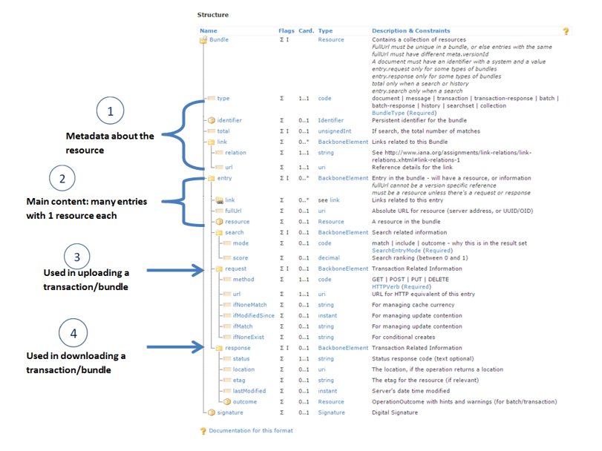

Figure – Example FHIR Bundle Content

Source <https://fhir-drills.github.io/bundle.html>

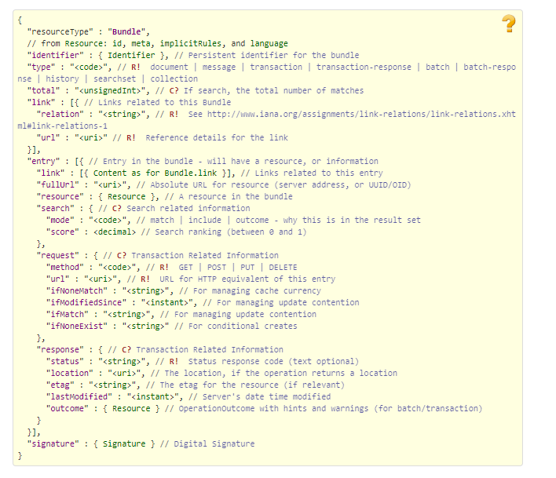

Figure – Example FHIR Bundle

Source <https://www.hl7.org/fhir/bundle.html>

## Communications Methods

### Ports and Protocols

#### HTTP(S)

Can be used for real time communication.

#### Advanced Message Queuing Protocol (AMQP)

AMQP offers reliable messaging via queues.

### ESB Configuration(s)

TBD

### System Configuration

TBD

## Performance Requirements

Please refer to the System Design Document (SDD); Medical Care Collection Fund (MCCF) - Electronic Data Interchange Transaction Application Suite (EDI TAS) <https://vaww.oed.portal.va.gov/pm/hape/ipt_5010/EDI_Portfolio/TASCore/MCCF_EDI_TAS_System_Design_Document_v0.7.pdf> if needed.

## Security

Please refer to the System Design Document (SDD); Medical Care Collections Fund (MCCF) - Electronic Data Interchange Transaction Application Suite (EDI TAS) <https://vaww.oed.portal.va.gov/pm/hape/ipt_5010/EDI_Portfolio/TASCore/MCCF_EDI_TAS_System_Design_Document_v0.7.pdf> if needed.

## Testing Requirements

All the QA testing activities are defined in tasks tied to acceptance criteria in a user story. For each testing category there will be a unique user story. The testing categories are:

1. Connectivity/Secuirity
2. End to End
   1. There might be 2 different End to End test run at different times.
3. Regression testing/Error handling
4. Volume testing
   1. Performance testing
   2. Endurance testing
   3. Load testing
5. Smoke testing

### Comparison of Data

Testing the FHIR conformance will be based on <https://www.hl7.org/fhir/validation.html>.

Business Rules will have to be specifically defined in user stories by the product team (TAS).

* Which fields are mandatory from a business perspective?
* Data integrity.
  + There are different approaches that TASCore can employ to test data integrity, depending on future user stories and tasks that will define requirements:
    - Comparing the source data with the output data.
    - Parallel testing: Run data through existing data flow and through the new data flow and make sure data match.
    - Conformance testing (FHIR)
    - Data conformity to business specs
      * Date format
      * Decimal places
      * Currency notations
      * Etc.
* Error handling

### Completeness

Tests defined in section 2.10.1 must cover all the FHIR resources that are defined in section 2.6.1 in consideration of any functional user story.

### Load Testing

Bench mark tests must be performed based on individual use case requirements.

## Policies and Constraints

### HIPAA Compliance

FSC receives transactions and then translates them into standard ASC X12N/005010 837 Health Care Claims message, validates whether the data complies with HIPAA standards and then forwards the claim data to the (HCCH).

# Appendix A

## Data Elements

Data being exchanged between TAS and FSC will be formatted in FHIR using the JSON notation. Data elements are mapped into fields in FHIR resources. FHIR resources will be located inside a FHIR bundle.

## Bundle (837)

Repeating fields within a segment need context definition so they can be differentiated within a segment. Also, repeating fields across multiple segments need to be differentiated. Following steps have been used to assign context to fields.

1. Identify the segment where the resource is located (Bundle.entry.extension.url="segment" and Bundle.entry.extension.valueString="837-EVN") [MessageType-Segment]

2. Where elements repeat within a segment use extension.valueString to identify field (Basic.extension.url="sequence" and Basic.extension.valueString="837-MSH-16" or Location.identifier.extension.url="sequence" and Location.identifier.extension.valueString="837-MSH-3") [MessageType-Segment-Field]

3. Repeating segments will include an incrementing id (MSA1, MSA2, ...)

### 837 Health Care Claims Bundles

JSON bundles for 837s

837I



837P



837D



## Resource Sections

### 837I Transaction Resources

#### Claim

See Claim resource in the 837I Bundle located in section 3.2.1

#### Condition

See Condition resource in the 837I Bundle located in section 3.2.1

#### Coverage

See Coverage resource in the 837I Bundle located in section 3.2.1

#### Encounter

See Encounter resource in the 837I Bundle located in section 3.2.1

#### EpisodeOfCare

See EpisodeOfCare resource in the 837I Bundle located in section 3.2.1

#### ExplanationOfBenefit

See ExplanationOfBenefit resource in the 837I Bundle located in section 3.2.1

#### Flag

See Flag resource in the 837I Bundle located in section 3.2.1

#### HealthcareService

See HealthcareService resource in the 837I Bundle located in section 3.2.1

#### Location

See Location resource in the 837I Bundle located in section 3.2.1

#### MedicationRequest

See Claim resource in the 837I Bundle located in section 3.2.1

#### Organization

See Organization resource in the 837I Bundle located in section 3.2.1

#### Patient

See Patient resource in the 837I Bundle located in section 3.2.1

#### PaymentReconciliation

See PaymentReconciliation resource in the 837I Bundle located in section 3.2.1

#### Practitioner

See Practitioner resource in the 837I Bundle located in section 3.2.1

#### Procedure

See Procedure resource in the 837I Bundle located in section 3.2.1

#### ReferralRequest

See ReferralRequest resource in the 837I Bundle located in section 3.2.1

#### RelatedPerson

See RelatedPerson resource in the 837I Bundle located in section 3.2.1

### 837P Transaction Resources

#### Basic

See Basic resource in the 837P Bundle located in section 3.2.1

#### Claim

See Claim resource in the 837P Bundle located in section 3.2.1

#### ClinicalImpression

See ClinicalImpression resource in the 837P Bundle located in section 3.2.1

#### CommunicationRequest

See CommunicationRequest resource in the 837P Bundle located in section 3.2.1

#### Condition

See Condition resource in the 837P Bundle located in section 3.2.1

#### Coverage

See Coverage resource in the 837P Bundle located in section 3.2.1

#### Encounter

See Encounter resource in the 837P Bundle located in section 3.2.1

#### EpisodeOfCare

See EpisodeOfCare resource in the 837P Bundle located in section 3.2.1

#### ImagingStudy

See ImagingStudy resource in the 837P Bundle located in section 3.2.1

#### Medication

See Medication resource in the 837P Bundle located in section 3.2.1

#### MedicationDispense

See MedicationDispense resource in the 837P Bundle located in section 3.2.1

#### Observation

See Observation resource in the 837P Bundle located in section 3.2.1

#### Organization

See Organization resource in the 837P Bundle located in section 3.2.1

#### Patient

See Patient resource in the 837P Bundle located in section 3.2.1

#### Practitioner

See Practitioner resource in the 837P Bundle located in section 3.2.1

#### Procedure

See Procedure resource in the 837P Bundle located in section 3.2.1

#### ReferralRequest

See ReferralRequest resource in the 837P Bundle located in section 3.2.1

### 837D Transaction Resources

#### Claim

See Claim resource in the 837D Bundle located in section 3.2.1

#### ClaimResponse

See ClaimResponse resource in the 837D Bundle located in section 3.2.1

#### Communication

See Communication resource in the 837D Bundle located in section 3.2.1

#### Condition

See Condition resource in the 837D Bundle located in section 3.2.1

#### Coverage

See Coverage resource in the 837D Bundle located in section 3.2.1

#### DocumentReference

See DocumentReference resource in the 837D Bundle located in section 3.2.1

#### Encounter

See Encounter resource in the 837D Bundle located in section 3.2.1

#### EpisodeOfCare

See EpisodeOfCare resource in the 837D Bundle located in section 3.2.1

#### ExplanationOfBenefit

See ExplanationOfBenefit resource in the 837D Bundle located in section 3.2.1

#### Flag

See Flag resource in the 837D Bundle located in section 3.2.1

#### HealthcareService

See HealthcareService resource in the 837D Bundle located in section 3.2.1

#### Location

See Location resource in the 837D Bundle located in section 3.2.1

#### MedicationRequest

See MedicationRequest resource in the 837D Bundle located in section 3.2.1

#### MessageHeader

See MessageHeader resource in the 837D Bundle located in section 3.2.1

#### Observation

See Observation resource in the 837D Bundle located in section 3.2.1

#### Organization

See Organization resource in the 837D Bundle located in section 3.2.1

#### Patient

See Patient resource in the 837D Bundle located in section 3.2.1

#### PaymentReconciliation

See PaymentReconciliation resource in the 837D Bundle located in section 3.2.1

#### Practitioner

See Practitioner resource in the 837D Bundle located in section 3.2.1

#### PractitionerRole

See PractitionerRole resource in the 837D Bundle located in section 3.2.1

#### Procedure

See Procedure resource in the 837D Bundle located in section 3.2.1

#### ProcedureRequest

See ProcedureRequest resource in the 837D Bundle located in section 3.2.1

#### RelatedPerson

See RelatedPerson resource in the 837D Bundle located in section 3.2.1

#### ValueSet

See ValueSet resource in the 837D Bundle located in section 3.2.1

### Mapping Sheet



A ‘.x’ in the valueString in columns H and K refers to the occurrence of the segment for repeating segments.

# Appendix B - TASCore Mapping Rules

## Mapping rules for Patient.gender

|  |  |
| --- | --- |
| VistA value | FHIR value |
| M | male |
| F | female |
| Everything other than M or F | unknown |

Used in

* + Resource: Patient
  + Field: Patient.gender
  + Segment: 837-CI2-SubscriberData
  + Field: 837-CI2-8-Subscriber Gender Code
  + Resource: Patient
  + Field: Patient.gender
  + Segment: 837-PT1-Patient Data
  + Field: 837-CI2-8-Subscriber Gender Code
  + 837-PT1-13-Pt. Gender Code

## Mapping rules for telecom.system

|  |  |
| --- | --- |
| VistA value | FHIR value |
| TE | phone |
| EX | other |

Used in

* + Resource: Organization
  + Field: Organization.contact.telecom.system
  + Segment: 837-PT2-Patient Data
  + Field: 837-PT2-9-Prop/Cas Contact Tele Qualifier
  + Resource: Organization
  + Field: Organization.contact.telecom.system
  + Segment: 837-PT2-Patient Data
  + Field: 837-PT2-11-Prop/Cas Contact Ext Qualifier

## DateTime types in FHIR

Certain values in FHIR resources use the type *dateTime*. *dateTime* types are a concatenation of date and time data.

***2017-09-25T20:25:11+00:00*** is an example.

For the FSC only the date part is relevant and the time part can be ignored.

Used in

* + Resource: Procedure
  + Field: Procedure.performedDateTime
  + Segment: 837-INS-Institutional Service Line Data
  + Field: 837-INS-10.x-Service Date From
  + Resource: Procedure
  + Field: Procedure.performedDateTime
  + Segment: 837-DEN1-Dental Service Line Data
  + Field: 837-DEN1-11.x-ORTHO BANDING DATE
  + Resource: Procedure
  + Field: Procedure.performedDateTime
  + Segment: 837-DEN1-Dental Service Line Data
  + Field: 837-DEN1-13.x-REPLACEMENT DATE
  + Resource: Procedure
  + Field: Procedure.performedDateTime
  + Segment: 837-DEN1-Dental Service Line Data
  + Field: 837-DEN1-15.x-TREATMENT START DATE
  + Resource: Procedure
  + Field: Procedure.performedDateTime
  + Segment: 837-DEN1-Dental Service Line Data
  + Field: 837-DEN1-17.x-TREATMENT COMPLETION DATE
  + Resource: Procedure
  + Field: Procedure.performedDateTime
  + Segment: 837-DEN-Dental Service Line Data
  + Field: 837-DEN-4.x-SERVICE DATE
  + Resource: Condition
  + Field: Condition.onsetDateTime
  + Segment: 837-DEN1-Dental Service Line Data
  + Field: 837-DEN1-9.x-PRIOR PLACEMENT DATE
  + Resource: EligibilityRequest
  + Field: EligibilityRequest.servicedDate
  + Segment: 837-CMN-Certificate of Medical Necessity
  + Field: 837-CMN-13.x-CMN LAST CERTIFICATION DATE
  + Resource: PaymentNotice
  + Field: PaymentNotice.statusDate
  + Segment: 837-CMN-Certificate of Medical Necessity
  + Field: 837-OI4-9.x-Other payer Check Date
  + Resource: Patient
  + Field: Patient.deceasedDateTime
  + Segment: 837-PT2-Patient Data
  + Field: 837-PT2-4-Insured or Pt. Death DT
  + Resource: Observation
  + Field: Observation.effectiveDateTime
  + Segment: 837-CL1-ClaimLevelData
  + Field: 837-CL1-25-Last Menstrual Period DT
  + Resource: Condition
  + Field: Condition.onsetDateTime
  + Segment: 837-CL1-ClaimLevelData
  + Field: 837-CL1-18-Onset of Current Illness/Symptom DT
  + Resource: Condition
  + Field: Condition.onsetDateTime
  + Segment: 837-CL1-ClaimLevelData
  + Field: 837-CL1A-8-Acute Manifestation DT (Spinal)
  + Resource: Procedure
  + Field: Procedure.performedDateTime
  + Segment: 837-CL1-ClaimLevelData
  + Field: 837-CL1A-2-Initial Treatment DT (Spinal)
  + Resource: ProcedureRequest
  + Field: ProcedureRequest.occurrenceDateTime
  + Segment: 837-PC1-ProcedureCodeData
  + Field: 837-PCx-2-Procedure DT

x in the field description refers to the occurrence of the repeating segment.

# Appendix C – TASCore Default Values

TBD

# Appendix D – FSC Mapping Rules

TBD

# Appendix E – FSC Default Values

TBD

# Glossary

|  |  |
| --- | --- |
| AMQP - Advanced Message Queuing Protocol | The Advanced Message Queuing Protocol (AMQP) is an open standard for passing business messages between applications or organizations using queues. |
|  |  |
| HCCH | Health Care Clearing House |
|  |  |
|  |  |
| REST | Representational State Transfer or RESTful web services provide interoperability between computer systems on the internet and other networks. Sometimes called ReST |

# Attachment A – Approval Signatures

This section is used to document the approval of the ICD. The review should be conducted face to face where signatures can be obtained ‘live’ during the review. If unable to conduct a face-to-face meeting then it should be held via Lync and concurrence captured during the meeting. The Scribe should add /es/name by each position cited.

By signing below, I agree that I have reviewed and agree the document is approved.

